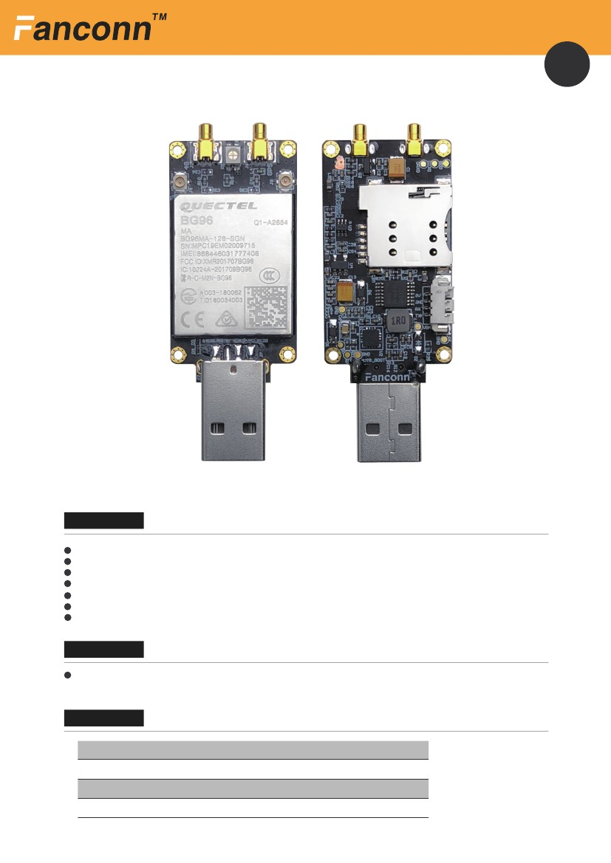ODM Development Customization
1
FANCONN BG96 Dongle
BG96 series
KEY FEATURES
Quectel BG96 Module
Small size 63mm×24mm
Support for multi-band and GPS*
LTE Cat M1 & Cat NB1 & EGPRS module with ultra-low power consumption
Support USB / UART transparent transmission two working modes
Industrial grade operating temperature, -40 to 85 degrees harsh environment
Supporting dual antennas
APPLICATIONS
Tracking and positioning, vehicle positioning management, equipment networking,
Specifications
Module
USB
SIM card type
Data rate
BG96
1×USB 2.0
Micro SIM
data rate of 375Kbps downlink and 375Kbps uplink.
Last Updated: 15/05/19
www.fanconn.com

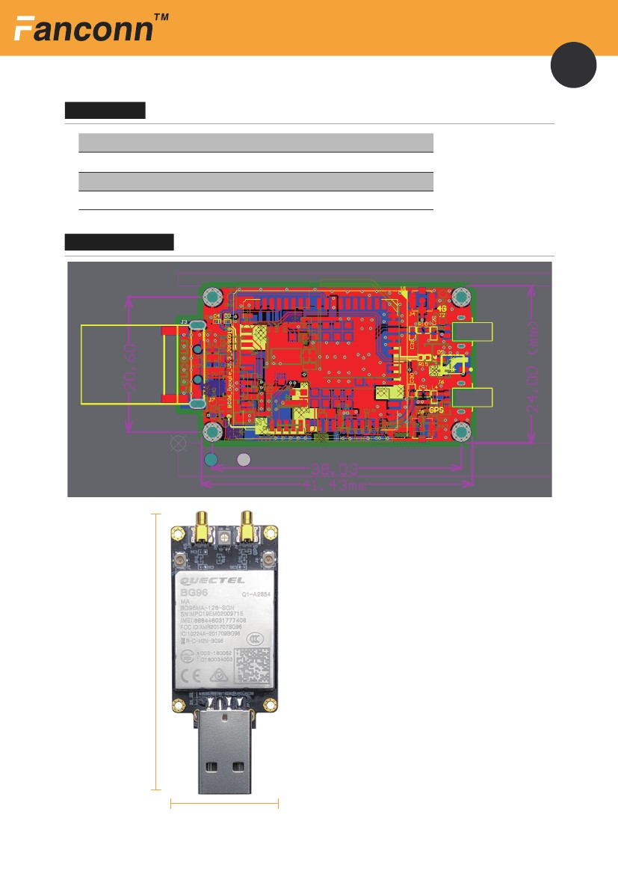ODM Development Customization
2
Specifications
range of working temperature
Power input
System Support
Uart Interface
-40 to 85 degrees harsh environment test
4.5V-6V
Windows XP/7/8/10, Linux 2.6/3.x/4.1~4.14, Mac OS
3.3V TTL
Dimensional Drawing
63mm
24mm
Last Updated: 15/05/19
www.fanconn.com

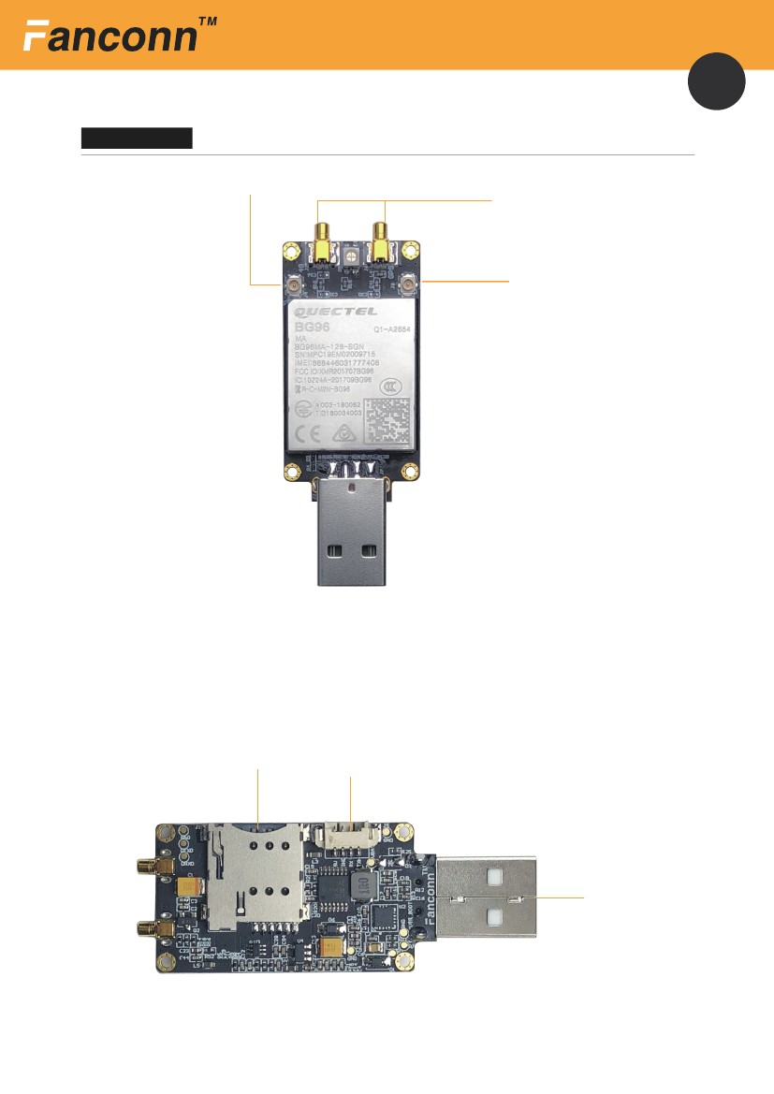ODM Development Customization
3
Component Map
GSM/GPRS/ multi-band
ts-9 Data antenna
Diversity antenna
Micro SIM
4P 1.27UART
VCC 5V
USB D-
USB D＋
GND
GND
Last Updated: 15/05/19
www.fanconn.com

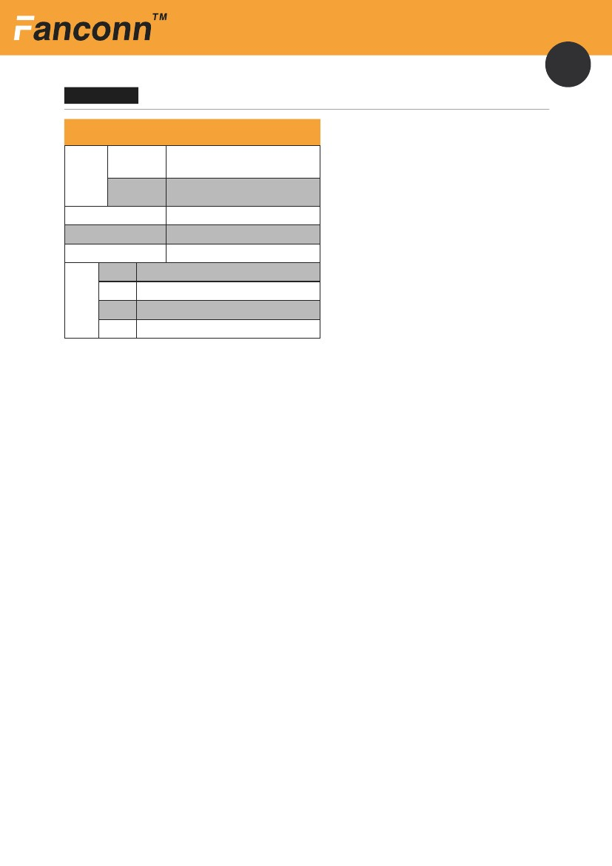ODM Development Customization
4
Specification
Frequency
FDD-LTE
LTE
TDD-LTE
B1/B2/B3/B4/B5/B8/B12/B13/B18/B19/B20/B26/B28
B39
EGPRS
Embedded GNSS
Region
850/900/1800/1900Mhz
Optional
Various regions
Cat M1
Cat NB1
DATA
EDGE
Max. 375Kbps(DL), Max. 375Kbps(UL)
Max. 32Kbps(DL), Max. 70Kbps(UL)
Max. 296Kbps(DL), Max. 236.8Kbps(UL)
GPRS
Max. 107Kbps(DL), Max. 85.6Kbps(UL)
While every effort is made to ensure the information is accurate,
FANCONN does not accept liability for any errors or mistakes that may arise.
All specifications are subject to change without notice
Fifth floor，NO. 17 Ruanjian road tianhe district，guangzhou，China
Last Updated: 15/05/19
www.fanconn.com

